Dear patient,

The NHS is experiencing some of the most severe pressures in its 75-year -history and this includes General Practice. There is a record demand for appointments which is causing unsustainable system pressures. As a practice we are doing our very best to continue to deliver a quality service with the resources that we have available to us. To help us continue to deliver a quality service there are things that our patients can do to “help us to help you”.

**Pharmacy First**

This is a new service that allows Pharmacists to supply prescription only medications and antivirals where clinically appropriate, to treat seven common health conditions:

* **Sinusitis – 12 years and over**
* **Sore throat – 5 years and over**
* **Earache – 1 to 17 years**
* **Infected Insect bites – 1 year and over**
* **Impetigo 1 year and over**
* **Shingles – 18 years and over**
* **Uncomplicated urinary tract infections in women 16-64 years.**

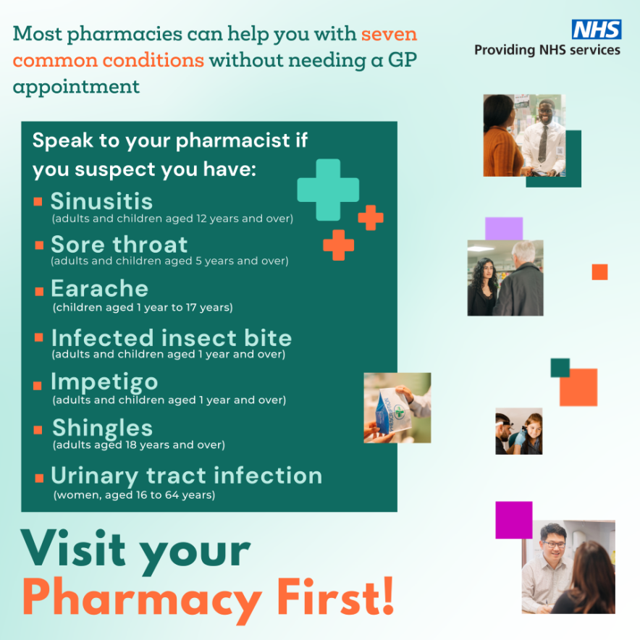

If you contact the practice with any of these conditions our Care Navigators in most cases can make you a direct referral to a participating pharmacy of your choice. Once the referral has been made to the pharmacy you will be provided with the contact number of your chosen pharmacy and will be able to contact them to book a consultation.

In some cases, the pharmacist can complete the consultation over the phone. Otherwise, a face-to-face consultation will be booked on the same day. This service can be more convenient for patients as they will not have to wait for an appointment at the practice and this helps free up appointments for those patients who need to be seen by a GP or nurse. You can find out more information on Pharmacy First here: [How pharmacies can help - NHS (www.nhs.uk)](https://www.nhs.uk/nhs-services/pharmacies/how-pharmacies-can-help/)

**Children**

Having an ill child can be a very scary experience for parents. However, if you understand more about the illness, it can help you to feel more in control.

1. **Fever** - Fever is a normal response that may even help fight infections. To lower their temperature, you may want to try giving them paracetamol and/or ibuprofen as well as removing all outer clothing. Don’t wrap your child up if they have a fever. Sponging your child with water can make matters worse as they can begin to shiver raising the temperature more. However, if sponging with lukewarm water doesn’t upset your child it may help a little.
2. **Chesty coughs/colds –** Coughs and colds are frequent occurrences in children, most colds and coughs don’t last long. 50% of children with a cough or cold will have recovered within 10 days and 90% recover within 15-25 days. One third of children who see a GP will still be coughing 2 weeks later, this doesn’t mean they need further treatment. Antibiotics do not help with common infections such as coughs/colds.
3. **Sore Throat –** A sore throat doesn’t need treatment to go away, it will heal by itself. 60% of children who see a GP with a sore throat will recover within 3 days. Large tonsils alone aren’t something to be concerned about. If your child seems very unwell or has a sore throat and temperature, but no cough for more than 3 days, he or she should see an ANP or GP. Furthermore, if your is having difficulty breathing or seems very unwell, you should seek medical advice urgently. 13 out of 14 children who take antibiotics for a sore throat will get better just as quickly as if they had not taken them.
4. **Earache –** You should only contact the surgery about earache if your child is having hearing problems or the ear is draining. Most ear infections in children resolve themselves within a week. Antibiotics generally don’t help symptoms, they only help in children under 2 with earache in both ears, and those with an ear infection that is draining.
5. **Not eating/Drinking –** Children often eat and drink less when they are unwell. Encourage them to drink plenty of water (not sugary drinks). Most will start to drink before dehydration. However, you should watch for signs of dehydration such as drowsiness, dry eyes/mouth, and decreased urination. This is especially important in children under 1 and those who are vomiting.

A child’s immune system is very powerful and will clear up most common infections by itself. You can help them by making sure they drink plenty of water, get lots of rest and offering them healthy foods like fruit and vegetables. For most common illnesses, paracetamol and/or ibuprofen can be given but be sure not to give them more than the maximum recommended dose of either.

If you are concerned about your child’s mental health, concentration or behaviours then please discuss these concerns with the school as they can provide counselling and assessments for Autistic Spectrum disorders and ADHD. Where we are asked to refer children with these conditions, we do so through the School Nursing team in the same way that the school does.

The links below provide some very useful information that will help parents manage their children’s health.

[https://www.alderhey.nhs.uk/conditions/symptoms-checker/](https://gbr01.safelinks.protection.outlook.com/?url=https%3A%2F%2Fwww.alderhey.nhs.uk%2Fconditions%2Fsymptoms-checker%2F&data=05%7C02%7Cjenna.howley1%40nhs.net%7C7ca16eea514343e7b86c08dc798192bc%7C37c354b285b047f5b22207b48d774ee3%7C0%7C0%7C638518844618062756%7CUnknown%7CTWFpbGZsb3d8eyJWIjoiMC4wLjAwMDAiLCJQIjoiV2luMzIiLCJBTiI6Ik1haWwiLCJXVCI6Mn0%3D%7C0%7C%7C%7C&sdata=XfXKm3ikaynOb1%2BehELWYvhg5X36ldwtd5LKieEim2c%3D&reserved=0)

[When should I worry-Booklet_England-with 111 service_2016.pdf](http://www.whenshouldiworry.com/resources/When%20should%20I%20worry-Booklet_England-with%20111%20service_2016.pdf)

[Home :: Healthier Together (what0-18.nhs.uk)](https://www.what0-18.nhs.uk/)

 **Dental Problems**

We know it can be hard to see a dentist, but we do not have the expertise to manage dental problems and we are advised that we should not prescribe antibiotics for dental problems, please see your dentist, or contact 111 for an emergency dental appointment.

**Acute Injuries**

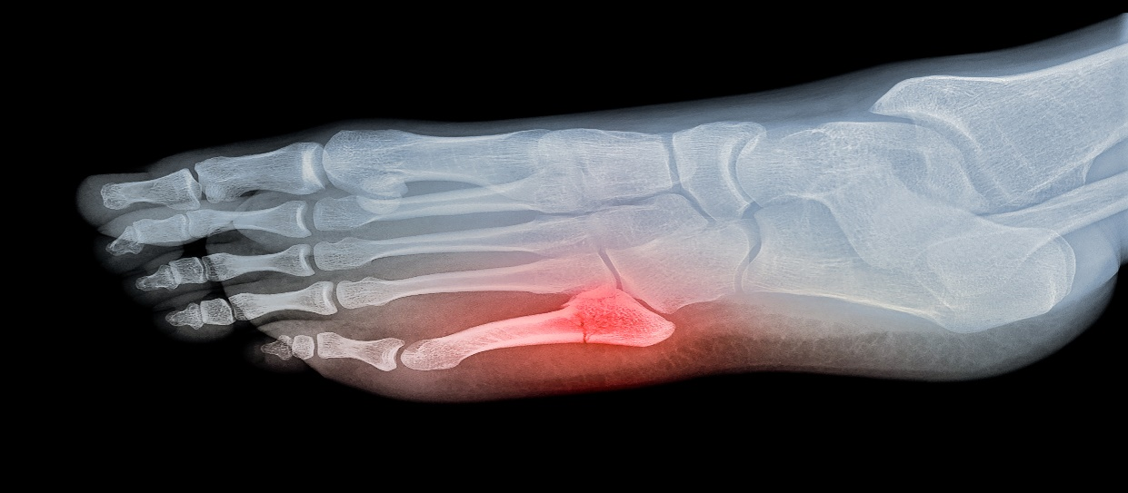

We are not permitted to request X-rays for injuries that are less than 2 weeks old. This is because X-rays are indicated if a fracture is suspected and if that is the case then the X-ray need to be reviewed immediately so appropriate treatment can be provided. It takes up to 10 days for us to receive an X-ray report whereas the images can be reviewed immediately in a Minor Injuries Walk- in Centre or A&E. If you have an injury and are concerned you may have a fracture, please attend a Minor Injuries Walk-in Centre or A&E where you can receive the assessment and treatment you need.

**Referrals**

When we refer a patient to hospital it is because we require the opinion of a specialist in how to manage your symptoms, or an investigation or treatment that we are unable to provide ourselves. If you have been referred for a hospital appointment, please wait for that appointment. We understand the wait for hospital appointments can be long, unfortunately this is a reflection of the pressure on the NHS as a whole and is the same for everyone. As a practice we have no control over hospital waiting lists and therefore we cannot speed up your hospital appointment, and booking an appointment to ask us to do so only adds to the pressure on our appointment availability. You can check the status of your referral via the appointments section of the NHS app.

The urgency with which someone is seen in hospital is defined by the clinical need and not the length of time that they are prepared to wait to be seen. When we refer, we do specify whether a patients symptoms require an urgent appointment or not. If your symptoms deteriorate significantly while waiting for a hospital appointment, then please book an appointment with a GP to reassess them. If your symptoms remain the same, then please wait for your hospital appointment.

If you have been seen by a specialist in the hospital and referred for investigations, please be aware that these results are not sent back to us. Your results will be returned to the hospital doctor who will arrange follow u as appropriate. It is difficult for the GP to comment on results requested by the hospital as they do not have the clinical information required to interpret these.

**NHS App**



Have you downloaded the NHS app yet? Did you know with the NHS app you can:

* Order medication
* Check appointments
* Cancel appointments
* Get your test results
* Check your medical record
* Look at health advice
* Contact the practice via Patchs
* Check the status of hospital referrals

Registering for the NHS app is quick and easy and can be done via smart phone or PC. You can register for this service via the link below. If you require any assistance in registering for this service, then please do not hesitate to contact us. We have an NHS app ambassador in the practice that is here to help you.

[NHS App and your NHS account - NHS (www.nhs.uk)](https://www.nhs.uk/nhs-app/)

**Prescriptions**

We deal with a high volume of prescription requests every week at Moreton Group Practice and this can be very time consuming. There are ways in which you can help us to reduce the amount of time our staff spend dealing with prescription requests.

1. We ask that you do not order your repeat prescriptions on the day you run out of medication, as prescription requests take 48 hrs to process. Please place your order when you have 10 days supply left. Pharmacies are also extremely busy so it may take an extra day for the pharmacy to prepare your medication after we have processed your prescriptions.

Remember to allow extra time for weekends and bank holidays.

1. Ordering your repeat prescription electronically via the NHS app saves time for both patients and the practice, as prescriptions that are ordered in this way are automatically sent to a GP inbox for signing. This is safer as it eliminates room for human error and will also help reduce the amount of time that our staff spend processing prescriptions. Only repeat medications appear on your app., if you have a new medication it may need to be reviewed by the GP before it can be moved to your repeat list.

We cannot accept prescription requests over the telephone unless you are registered as a Housebound patient with us. This is due to potential safety issues when transcribing the request, this method is also very time consuming.

Anyone who can not access online services is welcome to continue using the prescription boxes inside the building.

**Access to Medical records via the NHS app**

Patients who have the NHS app will now automatically have access to all medical information which has been added to their records after 30th October 2023. This includes consultation information, clinical letters, and results. If you do not already have online access, we would recommend downloading the NHS app. The NHS app allows you to verify your identity without attending the practice with proof of ID.

**Patchs**

Another way you can help us by reducing phone calls into the practice is to contact us using [PATCHS](https://patchs.ai/practice/moretongrouppractice). This is an online platform which you can access via the home page of our website or via the NHS app.

You can contact us via Patchs for clinical queries including requesting an appointment, or for admin queries such as requesting a fit note Monday – Thursdays from 7am till 8pm and Fridays 7am till 3:30pm (excluding bank holidays) You will just need to complete a few details about your issue and you will receive a response within 2 working days if not sooner.

Please do not call us to check if your Patchs request has been received by the practice – you will receive a notification letting you know this.

Anyone who cannot access or use online services can continue to call us on 0151 522 0099 or by visiting the practice in person.

**Please be kind to our staff as they are here to help you.**

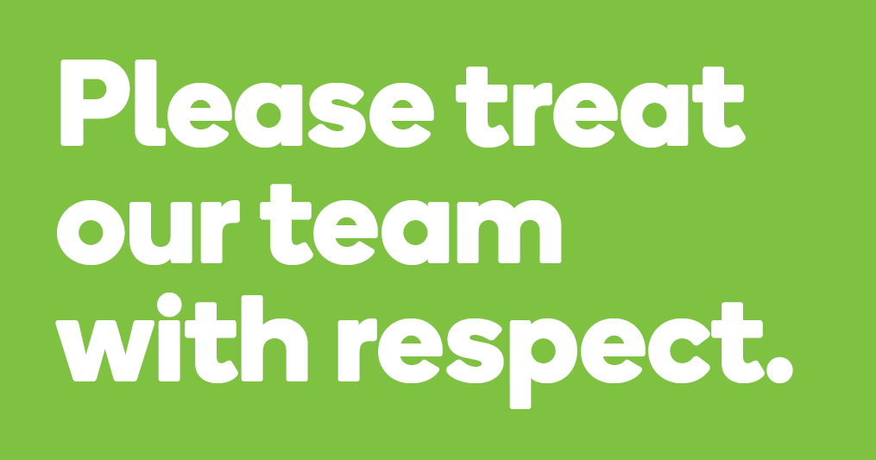

Whilst the majority of our patients are courteous and understanding, our team often bear the brunt of patient’s frustrations when they can’t see their preferred GP or when there is a wait for appointments. The team have no control over this and can only offer what is available and appropriate. When our team ask for details of the problem, this is so they can book you in with the right person at the right time.

We appreciate that you may not always be able to see your preferred GP when you call to book an appointment, The GPs in the practice work between 2 and 6 clinical sessions per week, some of these sessions will involve supervision and mentorship of our training GPs, planned care home reviews and on the day emergency clinics. So routine pre bookable appointments may be limited. The clinicians record comprehensive notes on your records so if you do need to see another doctor, they will be aware of previous discussions and plan. We ask that you don’t call on the day to request an emergency appointment to see a specific GP as these appointments are limited. You will be allocated a GP that has availability that day.

**Zero Tolerance**

Moreton Group Practice supports the Governments “Zero Tolerance” policy for Health Care Staff. This states that GPs and their team have the right to care for others without fear of being attacked or abused. We therefore ask that you treat our team with courtesy and respect. Aggressive behaviour, whether that be violent or abusive will not be tolerated and may result in you being removed from the practice list, and in extreme cases the Police will be contacted.

**Care Navigation**

We have a team of highly skilled and trained Care Navigators who will help patients to get the care that they need, at the time and place they need, with the person that they need. This ensures that you get the right care first time.

To be seen by the right healthcare professional, patients need to share details of their request with the team so we can work with them to get the right care. This isn’t always going to be with a GP. We have a team of additional healthcare professionals working with the practice who we may navigate you to. This includes Advanced Nurse Practitioners, Nurses, HCA’s, Clinical Pharmacists, Mental Health nurses, Health Coaches, Wellbeing Practitioners, Learning Disability Nurses, Diabetic Specialist nurse, Paramedic and Physician Associates. These additional roles enable patients to be seen by an appropriate professional and allows GPs to see more patients for acute problems.

**Missed Appointments**

We urge patients to please attend their booked appointments or to cancel so that the appointment can be offered to someone else. You can cancel your appointment by calling the practice, replying CANCEL to your reminder text or you can cancel via the NHS app.

**MGP Easter Bake off.**



During Easter we held a staff Easter Bake Off to raise funds for charity. This was a great success and we raised £81 which was donated to a former colleague who ran the London Marathon in April on behalf of the British Heart foundation.

**Relocation of GP Services**

Later in the year we will be moving all our services to Pasture Road Health centre. This move will reduce confusion for patients regarding which site to attend, increase staff peer to peer support and reduce costs for the NHS.

**Thank you!**

We would like to thank our patients for your continued support. We are always trying to improve our service to you, and we monitor feedback closely. So please let us know how we are doing by completing the Friends and Family Test feedback questionnaire about your most recent experience with us here: [Friends and Family Test Form « Moreton Group Practice](https://moretongrouppractice.co.uk/friends-and-family-test-form/)

**Kind regards and best wishes from all the team at Moreton Group Practice.**